Michael de Macedo Machado Wilson

Brazilian, 29 years old, Single

Rua Aperana, 56 ap 201, Leblon
Rio de Janeiro – RJ, Brazil – 22.450-190
Phone: 55 (21) 2512-1837 / 55 (21) 99634-2844
E-mail: michael@wilson.ms

Personal Experience

I grew up with family and friends, who taught me to see the value of things as they are and not judge by its appearance, admit when you are wrong, and always do the right thing. I thank them for being part of who I am today.

After my dad taught me how to surf, I passed it on to my cousins, sisters, girlfriends, and friends. Gradually, I learned how to film and edit surfing movies by myself, as computer programs were no challenge. In school, we learned how to do CPR, and practiced First Aid courses every year. I also received basic first aid training in the jungle for my mountain climbing and trail guide certificate.

Since little, my grandfather took me on boat trips through the coast, I always loved to be in the water. Later on a friend of mine showed me how to manage around the boat by myself. We head out and spend the weekends in his boat looking for surf and enjoying the layback life.

I graduated in business, and know a few things about how to run a company, where to find the customers and how to sell the product. My focus was on human development, training, and managing abilities. Hence, I know how motivation influences people and its surroundings. My yoga practices helped me understand how I can bring more happiness and harmony to my life and others around me.

After I started working and earned my own money, I spent my personal time searching for new experiences, looking for different cultures, and trying to absorb the most of it to bring back home with me. In return, I showed the people who I met my world and opened their eyes to places they would never see otherwise. Today, I live for these moments; sharing knowledge is priceless and ageless.

After I came back from my last surf trip, something did not feel right, my spirit wanted more. Now, I am seeking for a different experience. While planning my next trip I realized it would take more than a two week trip to suffice this feeling. So I started looking for jobs that could give me what I was looking for.

Although I can’t complain about it, the life in the city has worn me out. Watching the days go by through a window, sitting in front of a computer is hardly considered living. And I want to live to work, not the other way around. I want the opportunity to learn more about myself, and contribute to helping others make their life better.

Personal References

Contact: Pedro Garcia Contact: Patrick Vianna
Relationship: Friend Relationship: Friend
Telephone: 55 (21) 99504-7074 Telephone: 55 (21) 99234-7456

Contact: Marcio Rosseti Contact: Rafael Vilaça
Relationship: Yoga Instructor Relationship: Godfather
Telephone: 55 (21) 98220-3630 Telephone: 55 (21) 99911-0166

Languages

Fluent in English, and Portuguese (speaking, reading, writing and comprehensive skills)
Proficient in French, and Spanish

Hobbies & Skills

Filming – Surf sessions (on boat, in water, on land), Trips, Public Events (Carnival in Rio)
Video Editing – Surf sessions, Trips, Surfing Trips, Public Events
Photography – Surfing, Landscapes
Writing – Short stories, articles
Drawing – Anything that comes to mind
Cooking – Typical Brazilian, and Italian meals
Music – Guitar, bass, and percussion player

Sports Experience

Diving July 2011
Experience: Beginner

SwaSthya Yoga April 2011
Experience: Intermediate

Mountain Climbing April 2010
Experience: Intermediate

Muay Thay - Kickboxing June 2000
Experience: Advanced

Longboard Skate Downhill November 1998
Experience: Advanced

Shortboard / Longboard Surfing October 1998
Experience: Advanced

Technology Experience

Proficient knowledge in: Microsoft Office System, Lotus System, Video Editing Programs

Academic Experience

PUC-RIO – Pontifícia Universidade Católica do Rio de Janeiro August 2003 - June 2009

Business Administration

EARJ – American School of Rio de Janeiro February 1991 - June 2003 American and Brazilian Diploma

Professional Experience

Deloitte Touche Tohmatsu September 2012 - Present
Position: Senior Tax Consultant

Contact: Orlando Velasco
Position: Tax Manager
Telephone: 55 (21) 99587-0396

Deloitte Touche Tohmatsu September 2009 - August 2012
Position: Tax Consultant

Contact: Bruno Menezes
Position: Senior Tax Consultant
Telephone: 55 (21) 98832-7000

CASE Consulting: Executive Search July 2008 - September 2008
Position: Headhunter

IBM Global Financing July 2007- June 2008
Position: System Administrator

Contact: Alexandre Espirito Santo
Position: Siebel Team Coordinator
Telephone: 55 (21) 3504-7000

Photos

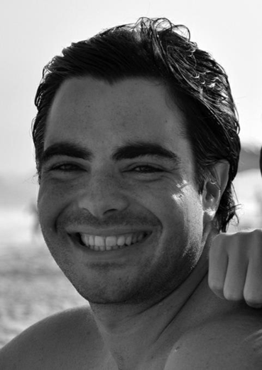

Profile

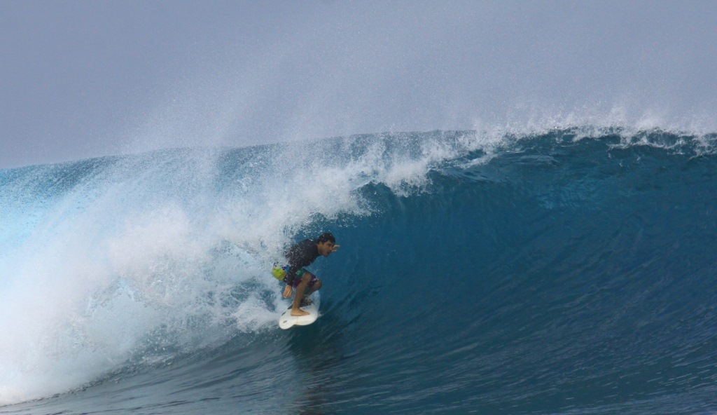

Surfing

